Exercsise sports health and nutrition: Cardiac Physiology
Dr. Andrew Cave, fellow in Pediatric Cardiology at OHSU
Dr. Kathryn Holmes, assistant Professor of Pediatric Cardiology at OHSU

- Review blood flow through the heart and the body (2.3)
  - Relationship between pulmonary and systemic circulation (2.24)
  - Blood supply to the heart and the lungs
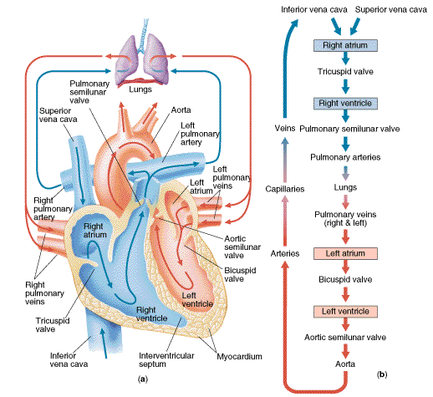
http://anatomyofthefoot.com/wp-content/uploads/2016/08/diagram-of-blood-flow-through-heart-kleczekbiology-circulatory-system.gif

NOTES:

- Review electrical signals in the heart, the ECG
  - P wave - Atrial depolarization
  - QRS complex - Ventricular depolarization
  - T wave - Ventricular repolarization
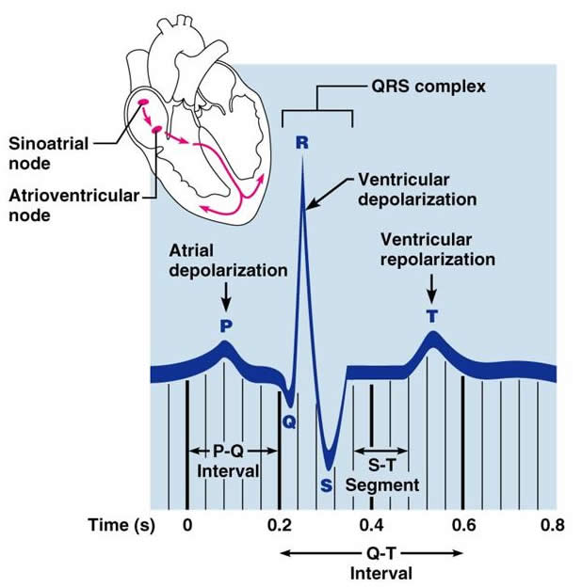

http://classes.midlandstech.edu/carterp/Courses/bio211/chap18/Slide19.jpg

NOTES:

- Regulation of heart rate (2.24)
  - Heart has it’s own pacemaker (intrinsic regulation)
  - Sympathetic and parasympathetic nervous systems override the natural pacemaker (extrinsic regulation)
  - Difference in heart transplant - nerves are cut.
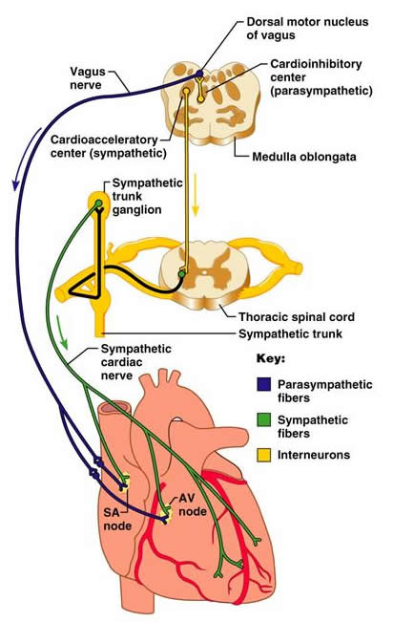
http://classes.midlandstech.edu/carterp/Courses/bio211/chap18/Slide18.jpg

NOTES:

- When the heart pumps, it creates pressure in the arteries (2.29):
  - Systolic blood pressure: the force exerted by the blood on the arteries during ventricular contraction
  - Diastolic blood pressure: the force exerted by the blood on the arterial walls during ventricular relaxation

  - NOTES:

- Estimation of Cardiac Output (2.26- 2.27))
  - Cardiac Output = Stroke Volume x Heart rate
  - What happens in different populations
    - Trained versus untrained athlete (2.213)
    - Young versus old

NOTES:

- Introduction to Echocardiography - you tube video: https://www.youtube.com/watch?v=gsW4Ox-RPK4
  - Echo demonstration - with ecg
  - Cardiac output by echo

  - NOTES:

- Physiologic Response to Exercise LAB
  - HR
  - BP
  - Blood pool

